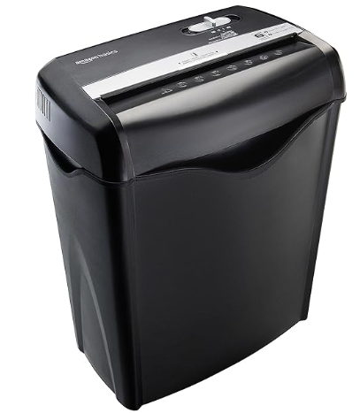

**June 10, 2024**

**Two Events To Keep You Safe!**

**Pittsboro Center for Active Living**

A shred truck will be at the **Pittsboro Center for Active Living, 365 Hwy 87 N, Pittsboro, NC 27312** from **8:30am – 12:30pm** or until the truck is full.

25 free shredders will be given away at the event .

**Chatham County Community Library**

Join us for a Scam Alert event **from 2:00 – 4:00pm** in the

**Holmes Meeting Room** of the **Chatham Community Library, 197 Hwy 87 N, Pittsboro, NC 27312.**

Guest Speakers will provide tips and tricks to avoid scams and fraud.

* NC Department of Insurance
* Senior Medicare Patrol
* Chatham County Sheriff’s Office

**Contact us at 919-742-3975**

**Chatham County SHIIP – Lawana Schulze**

