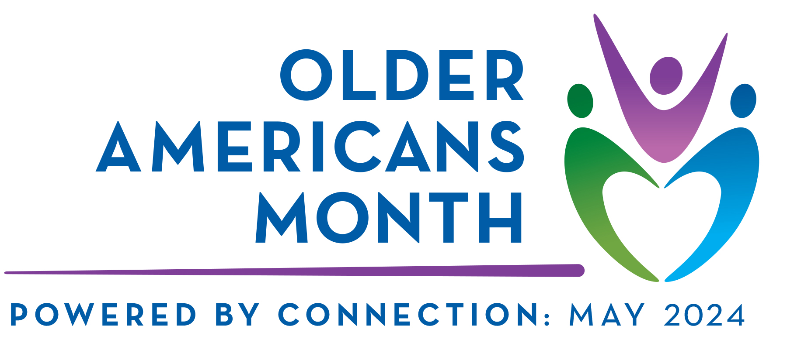

Senior Services

Save the Date
Wednesday, May 1st, 2024 – 9:30 a.m. – 1:30 p.m.
Duplin Events Center – 195 Fairgrounds Dr., Kenansville, N.C. 28349

In celebration of Older Americans Month, we extend this invitation to “Seniors” in Duplin County. This is a great opportunity to encourage social interaction, have some fun, and shred some important documents.

Program Schedule
9:30 a.m. – Light refreshments

9:30 a.m. 11:15 a.m.
A variety of activities will be available to include a photo booth snapshot, cornhole games, music/dancing, project painting, and health screenings/resources.

10:00 a.m. – 1:00 p.m. – SHRED A THON event (outside)

11:30 a.m. Guest Speaker, Ms. Stephanie Bias, North Carolina Senior Medicare Patrol

11:45 a.m. – Duplin Sparklers Senior Line Dance Team

12:00 Noon – Lunch Served
Seniors must be present to win door prizes!

